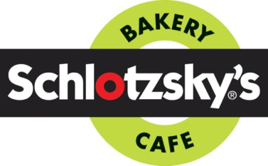

Monday:

Schlotzsky’s

Meal: Turkey Sandwich with cheese & Chips

Price: $8.00

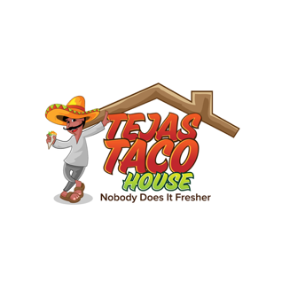

Tuesday:

Tejas Taco

Meal: 2 Chicken Fajita Tacos with Rice, Beans, & Queso

Price: $8.00

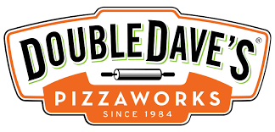Wednesday:

Double Dave’s

Meal: 1 Slice of Pizza & 1 Cheesy Breadstick

Price: $8.00

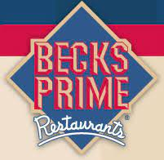

Thursday:

Beck’s Prime

Meal: Cheeseburger & Chips

Price: $8.00

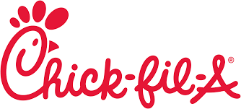Friday:

Chick-fil-a

Meal: Chicken Sandwich & Waffle Chips

Price: $8.00