Rookie Camp: Rookie Camp is a special camp for our 5 and 6 years old. Your rookie camper will have the opportunity to try new fun activities throughout the summer! Campers will also participate in our weekly themed events and Chapel on Wednesday mornings. We will also be offering swim lessons for your rookie camper if needed. If not, they will be on a rotating schedule of physical or enrichment activities during the ‘Specialty Camp’ time period.



Basketball: (Ages 7 & up) During this time, your camper will be taught the basic techniques of shooting, dribbling, passing, rebounding and defense of basketball. This ‘Specialty Camp’ will not only provide a fundamental base for each young player but will also be a fun and enjoyable experience for every camper.

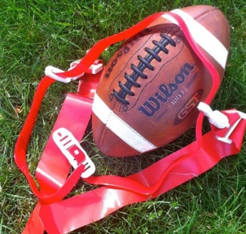

Flag Football: (Ages 7 & up) During this ‘Specialty Camp’, your camper will have the opportunity to try all positions of flag football. Campers will rotate through a variety of drill stations to practice the fundamental skills of all positions. Campers will then get a chance to test out their new skill at the end of the week in a flag football game.

Martial Arts: (Ages 7 & up) NEW CLASS ALERT: Martial arts is an excellent way for your camper to learn discipline, build strength, confidence, make new friends and develop new interests. This summer, Quillian Center’s very own Uche Nzeribe Sr. will be teaching our campers the basics of martial arts.

Cooking/Baking: (Ages 7 & up) Baking is a science where every ingredient has a function and in this ‘Specialty Camp’ we are excited to explain why. In this fun filled class, students will learn the basics of baking including proper measuring and mixing techniques, and food science facts that affect their final product.

Q-Fit: (Ages 7 & up) Do you like to work out? Do you like to move? This specialty camp is for you! Throughout the week our Q-Fit class will get moving and work our muscles! We will introduce our campers to a different type of movement that contains strength, conditioning, and positivity.

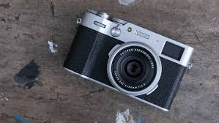Photography: (Ages 7 & up) Throughout the week, campers will learn the necessary skills to research, compose, and capture the perfect digital picture through a lens! Campers are encouraged to be creative and think outside the box during this ‘Specialty Camp’, but we also want to teach them that each project is a work of art.

Drama: (Ages 7 & up) Lights, Camera, Action! This specialty camp is the ones our actors or actresses need to sign up for! Throughout the week they will learn different techniques regarding theatre/drama, preparing small skits and plays, and learning all about the performing arts! At the end of the week, the campers will perform a small skit in front of their peers!

Pottery: (Ages 7 & up) NEW CLASS ALERT: Pottery gives the opportunity for the campers to be creative and learn a new form of art. You can either make containers, sculptures, and other objects out of clay. Each camper will take home their project at the end of the week!

Robotics: (Ages 7 & up) R2-D2, is that you? Robotics is a specialty camp that Quillian is bringing back! During the week, your camper will explore a branch of engineering that lets them think out the box and design a “robot”!

Jewelry Making: (Ages 7 & up) Jewelry Making gives the opportunity for students to think outside the box and express themselves through what they can make and wear! This is a fun opportunity to learn a new skill and share it with others. During this specialty camp, they will learn the basics of jewelry-making such as, designing, knotting and bead work; by the time this is over they will have their own handmade jewelry to keep! Happy designing!

Softball: (Ages 7 & up) Softball is like baseball in many ways! But softball has a small field and is played with a larger, softer ball. If you want to try this sport out, sign up! Quillian Center staff would love to teach you all about it!

Science: (Ages 7 & up) Learning science should be messy and a full of “OOOOOHHH’S” and “AAAAAHHH’S”! This specialty camp is exactly that. Campers will spend the week conducting science experiments and creating projects that are hands-on and mind-blowing. We promise we won’t turn your camper into a mad scientist by the end of the week!

Soccer: (Ages 7 & up) What to score a goal this summer? Our soccer camp specialty is the one for you! Our soccer coaches will work with your young athlete to improve their soccer techniques with skills and drills such as, dribbling and passing, receiving the ball on the ground and in the air, and shooting tips and tricks. I can’t wait to hear all the campers scream “GOOOOAAAAAALLLLLL” when someone scores this summer!

Music: (Ages 7 & up) Do you like to jam out, sing or play an instrument? This specialty camp is for you! Throughout the week, your camper will learn the ins and outs of music. This class will be taught by Kera Academy and FUMC’s very own Anthony Rogers (our head musician).

Golf: (Ages 9 & up) Bring your clubs, we are heading to the local driving range! If you are wanting to learn how to chip, putt, hit iron shots and learn how to properly play golf; this is the specialty camp for you! Campers will be taken to the local driving ranges throughout the week by bus. Get those crazy golf pants out and get ready to practice that swing!

Volleyball: (Ages 7 & up) Bump it, Set it, SPIKE IT! Our volleyball specialty camp is taught through drills and exercises that focus on passing, setting, hitting and serving the ball. Our volleyball coaches will assist each camper with developing those skills. By the end of the week, your camper will be rotating around the volleyball court like a pro!

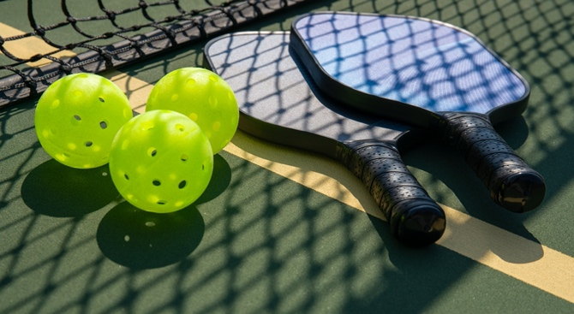Pickleball: (Ages 7 & up) Do you like ping pong? Do you like tennis? WELL, this is the perfect pick for you! Pickleball is a paddleboard sport that combines element of badminton, table tennis, and tennis. Throughout the week, your camper will learn the rules of pickleball, how to use the equipment properly, how to set up the court and how to play! Get ready to LOVE this sport, because Quillian sure does!

Baseball: (Ages 7 & up) “Take me out to the ball game, take me out with the crowd”; your camper will be singing this and wanting to go to baseball games after this specialty camp! During the week, our campers with learn the basics of throwing, catching, hitting, pitching and so much more! Can’t wait to see you out on the field!

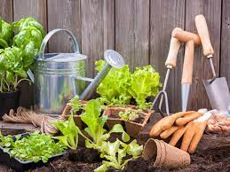Gardening: (Ages 7 & up) Do you have a green thumb or a love for plants? Let’s make this Earth a greener place! Throughout the week, your gardener will learn the basics of keeping plants alive, what soil is best for different plants, and will even get to take their own plant at the end of the week! We will also be taking a trip to Woodchase Park to help care for Quillian’s raised garden there! Get your gardening gloves ready!

Mixed Media Art:(Ages 7 & up) Calling all artist! This specialty camp is a MUST for you! During the week, campers will be learning all the supplies needed to achieve mixed media art. From paper to paints, to watercolors or acrylic paints, you will learn how to use it all. This specialty camp makes you think outside the box and lets you express yourself through your art! Remember, creativity takes courage!

Sewing (NEW CLASS ALERT) (Ages 7 & up) This specialty camp is all about sewing and fabric work. Each camper will learn the basics about sewing and fabrics. This class will be taught by some amazing ladies that teach sewing to our community! Each camper will get to take home their final project at the end of the week!



Kid City: (Ages 7 & up) Do you like exploring? Do you want to learn more about our city? Kid city will give you that! Each day different businesses will be opening their doors to our campers and giving them behind the scenes tours and access to things only employees can see. Campers will get to see what it takes for businesses to run and operate daily!

Glam Camp: (Ages 7 & up) Do you like bath bombs, DIY skin care or relaxing? Glam camp is going to give you all that and more! Throughout the week, campers will learn how to make bath bombs, body scrubs and so much more! This is a time to take a deep breath and relax after a long school year.

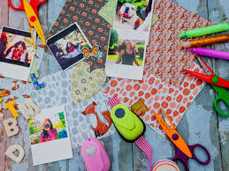

Scrapbooking: (Ages 7 & up) Do you want to save those memories you made a few years ago? Bring in those photos and make a scrapbook out of them! During this time, your camper will learn how to make their memories last a lifetime with a scrapbook. We are excited to see what ideas you come up with!

Dance: (Ages 7 & up) Ready to hit the dance floor and learn some moves? Campers will learn dances styles from contemporary, jazz, and hip hop. Our dancers will get to light up the stage at the end of the week with a fun dance performance! Can’t wait to see you on the stage, you’re going to crush it!

Tabletop Games: (Ages 7 & up) Do you like playing board games or card? Sign up for this specialty camp! Throughout the week, your camper will learn how to play different board game and card games! They can even share what they learn with the family!

Cheer and Tumble: (Ages 7 & up) Five, Six, Seven, Eight! One, Two, Three, Four! Those are the simples counts that Cheerleaders and Tumblers use to help memorize their routine and help them stay on beat. Throughout the week we will be working on proper stretching and then learn basic tumbling techniques and cheers.

Veterinary Science: (Ages 7 & up) Are you interested in animals? Do you want to be a Vet one day? Well, sign up for this class, NOW! Throughout the week, campers will learn how veterinarians take care of certain animals, what they do to prevent sickness, and a trip to a local animal shelter to meet a local veterinarian!

Tennis: (Ages 7 & up) Get your rackets ready, we are playing tennis at our local tennis courts this summer! Throughout the week, campers will learn the proper rules, footwork, strokes and serves regarding tennis. Make sure to bring a water bottle and a go-get-em’ attitude!

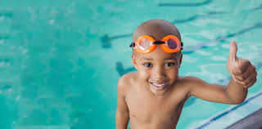

Swim Lessons: (All ages) During summer camp, we will be offering swimming lessons taught by a company that specializes in it. We will not be offering them every week, but when they are you may sign your camper up for them. We encourage our 5-6 years old to participate. If you are older, that is totally fine as well. Make sure to bring your swimsuit and towel!

\*\* Swim lessons will only be offered during the month of June\*\*

VBS: (All Ages) Vacation Bible School (VBS) is hosted by the First Methodist Church for one week out of the summer. During VBS, they will participate in games, arts and crafts, and Bible stories! If you have any questions about this, please feel free to ask!